“With Office Project Server 2007, we know the number and mix of staff members needed, and even the total cost of a project before we take it on.”
Customer: University of Southern Mississippi
Web Site: www.usm.edu
Customer Size: 14,000 students
Country or Region: United States
Industry: Education
Partner: PSG Government Consulting

Customer Profile
The University of Southern Mississippi provides higher education services to more than 14,000 people along the Mississippi Gulf Coast.

Software and Services
- Microsoft Office
- Microsoft® Office Project Professional 2007
- Microsoft Office Project Server 2007
- Microsoft Server Product Portfolio
- Windows Server® 2003
- Microsoft SQL Server™ 2000
- Technologies
- Microsoft Office Project Web Access
- Microsoft Windows® SharePoint® Services
For more information about other Microsoft customer successes, please visit:
www.microsoft.com/casestudies
Homer Coffman, Chief Information Officer, University of Southern Mississippi
The University of Southern Mississippi is a research university with a student body of more than 14,000. The IT department was besieged with more requests than it could fulfill, resulting in incomplete projects and unhappy internal customers. Since implementing the Microsoft® Office Enterprise Project Management Solution, the IT staff is making better strategic decisions, completing more projects, and boosting staff productivity by 40 percent.

Business Needs
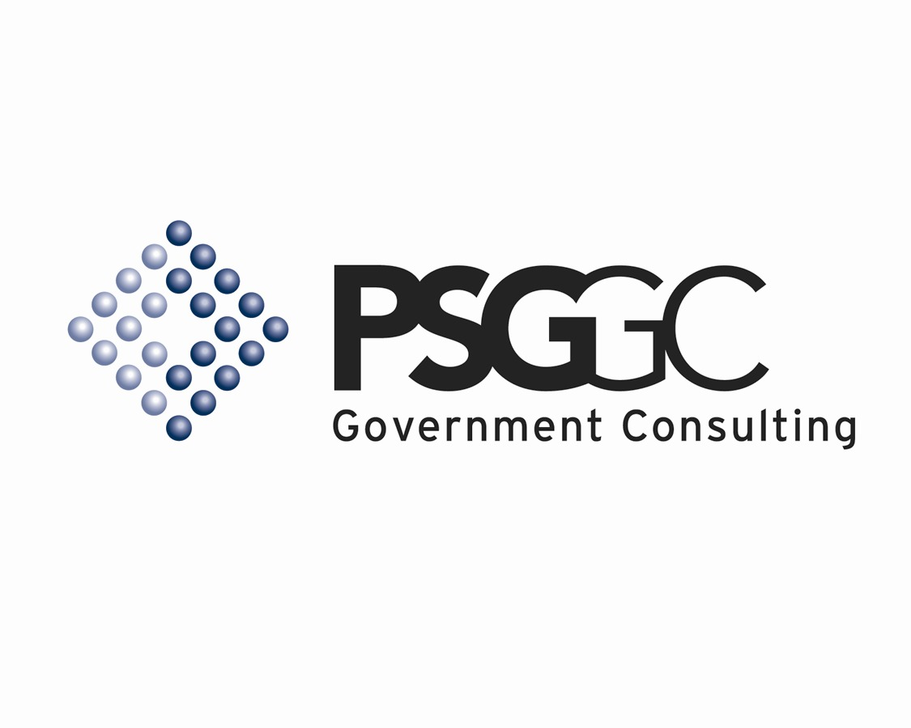 |  |  | 

The University of Southern Mississippi (USM) offers higher education opportunities throughout the Gulf Coast region of Mississippi. In addition to its main campus in Hattiesburg, USM has two other campuses and six teaching sites, serving a statewide student population of more than 14,000.

The school’s IT department, iTech, receives hundreds of project requests each year from 134 university departments. However, iTech lacked a system for project and portfolio management, which made life for its approximately 100 staff members frantic, frustrating, and often fruitless. “When I came on board two years ago, we had 334 unfinished projects, because our people were constantly in reactionary mode,” explains Homer Coffman, Chief Information Officer at USM. “We had [U.S.]$20 million worth of requests on an $8 million budget. We were saying ‘yes’ to everything and getting very little of it finished.”

Coffman instituted an IT governance structure, with the aim of creating a sense of strategic priority in the department and giving managers the information they needed to do better planning, forecasting, and project management. “I wanted to be more responsive to our internal customers and make my staff feel better about its accomplishments,” he says.

In 2005, the department acquired Microsoft® Office Project Professional 2003 for individual project managers. However, only some project managers used the product and then not to its full advantage. In addition, iTech was not able to use the desktop-centric Project Professional 2003 to get a strategic view of projects departmentwide. “It was always a guess as to the resources needed to run a complex organization,” Coffman says. “It sounded like we were whining, when in fact we were drowning.”

Solution
Coffman committed to tapping the full potential of the Microsoft Office Enterprise Project Management Solution by upgrading to Microsoft Office Project Professional 2007 and adding Office Project Server 2007. Working with PSG Government Consulting, a Microsoft Certified Partner from Vienna, Virginia, Coffman’s staff implemented the solution in late 2006.

Through use of Office Project Server 2007, the iTech staff has a better strategic view of its projects and can manage projects better day to day. When a project request comes in, the iTech staff performs an initial assessment to determine funding requirements. “The assessment allows us to better align customer expectations with resources and give customers an accurate completion date,” says Allen Chamberlain, iTech Project Manager.

Office Project Professional 2007 gives project managers extensive project management tools such as red, yellow, and green indicators to help them instantly grasp and measure schedules and budgets. “This solution enables project managers and executives to identify areas of overlap between project dates and resources, and to schedule initiatives in such a way as to minimize the burden on USM resources,” Chamberlain says. “This reduces risks, gives managers insight into project schedules and resources, and improves the likelihood that a project will be completed on time and on budget.”

One major project: The school’s Long Beach, Mississippi, campus was nearly destroyed by Hurricane Katrina, and USM plans to use Office Project Server 2007 to manage the rebuilding of 32 buildings.

Microsoft Windows® SharePoint® Services, part of the Windows Server® 2003 operating system, provides a browser-accessible place to store all project-related documents. Microsoft Office Project Web Access and Project Workspaces help team members collaborate over the Web. Microsoft SQL Server™ 2000 is the data repository.

Benefits
With its new project management solution, the iTech department at the University of Southern Mississippi has been able to lower project risk and increase its project completion rate, improve resource management, realize $66,000 in annual productivity savings, and better meet customer needs.

- Reduced project risk, higher completion rate. With the Office Enterprise Project Management Solution, USM iTech will improve its on-time project completion rate. “We can identify trends and problem areas and make tradeoffs to ensure the success of a group of projects,” says Chamberlain. “We can efficiently handle the constant change in priorities for all projects and tasks.”

- Better resource management. “With Office Project Server 2007, we know the number and mix of staff members needed, and even the total cost of a project before we take it on,” Coffman says. “We now have the data with which to make the best possible use of resources and to justify additional resources.”

- U.S.$66,000 annual productivity savings. The solution helps everyone in iTech be more productive, because staff members spend less time on manual processes such as creating reports, and more time on actual project work. “I estimate that project managers are saving 10 hours a week entering task assignment data, generating reports, and tracking down information,” Coffman says. “That’s worth $46,000 annually to USM. Timesavings for the rest of the staff will add another $20,000 in annual productivity-related savings.”

- Improved customer satisfaction. The university’s internal customers are happier, because they get a more accurate sense of when projects will be delivered. “We still have too few people being asked to do too much work, but this system has allowed us to better align expectations to our budget and provide realistic deliverables,” Coffman says. “Customers are happier in the end because we are not overpromising, and we’re delivering higher quality projects.”

